For immediate release News media contact: Leslie Braunstein,
202/656-0542, info@lhbcommunications.com

Jennie Hawkins, Kate Costello Join UIP Property Management

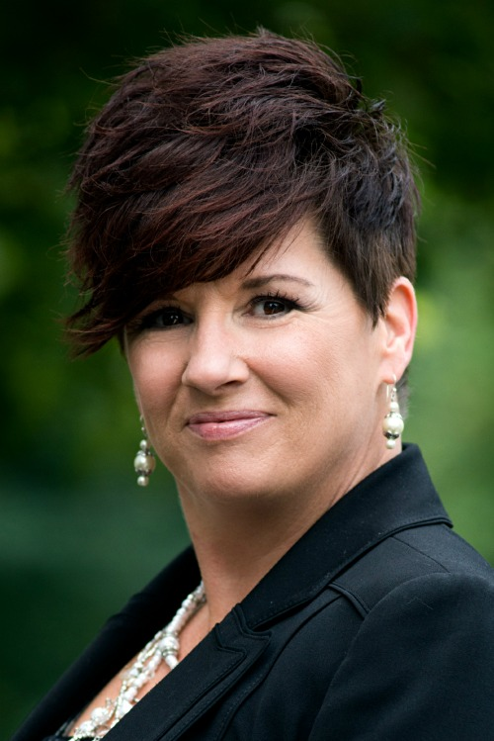
Washington, DC, October 28, 2014-- UIP Property Management, Inc. (UIPPM), a subsidiary of the UIP Companies, Inc. of Washington, DC, has appointed Jennie Hawkins Vice President of Operations, serving as effective head of UIPPM. Kate Costello was hired as Regional Manager for UIPPM, supervising all of UIPPM’s property management staff.

Ms. Hawkins joins UIPPM from Sawyer Realty Holdings of Newton, MA, where she served as Senior Regional Manager for Sawyer’s Mid-Atlantic Holdings, leading and coaching a team of professionals responsible for thousands of multifamily assets. Earlier, she worked for leading Washington, DC area firms The Donaldson Group and Southern Management Corporation. She graduated Summa Cum Laude from Ashford University with a BA degree in organizational management.

Ms. Costello worked most recently with Harbor Group Management Company of Norfolk, VA, overseeing more than 4,000 multifamily units with a valuation of $335 million. Before that, she served as a regional property manager for Continental Realty Corporation of Baltimore, MD. She holds a BA degree from Elon College and serves as a guest lecturer at Johns Hopkins University, Georgetown University, and the University of Baltimore.
“We are very excited to expand our property management capabilities and provide greater organizational structure at UIPPM,” said Pete Bonnell, Principal, UIP. “Jennie and Kate bring our property management group a new level of experience and authenticity that we believe can help us implement our vision.”

UIP manages approximately 3,000 apartments in the Washington, DC region and has renovated and restored more than 20 downtown apartment buildings over the last eight years. UIP’s primary focus is working with tenants in Washington, DC and helping them exercise their TOPA (Tenant Opportunity to Purchase Act) rights as well as entitling land and developing new projects and acquiring residential assets in the close-in Washington, DC suburbs. For more information, visit www.uipllc.com and www.uippm.com.

Photos: Top: Jennie Hawkins; Bottom: Kate Costello

