  

For immediate release News media contact: Leslie Braunstein,

202/656-0542, [info@lhbcommunications.com](mailto:info@lhbcommunications.com)

Company contact: Steve Schwat, 202/684-7840

**UIP, PRP, AND PERSEUS REALTY ACQUIRE 289-UNIT CAPITOL PARK TOWERS APARTMENTS IN SOUTHWEST WASHINGTON, DC**

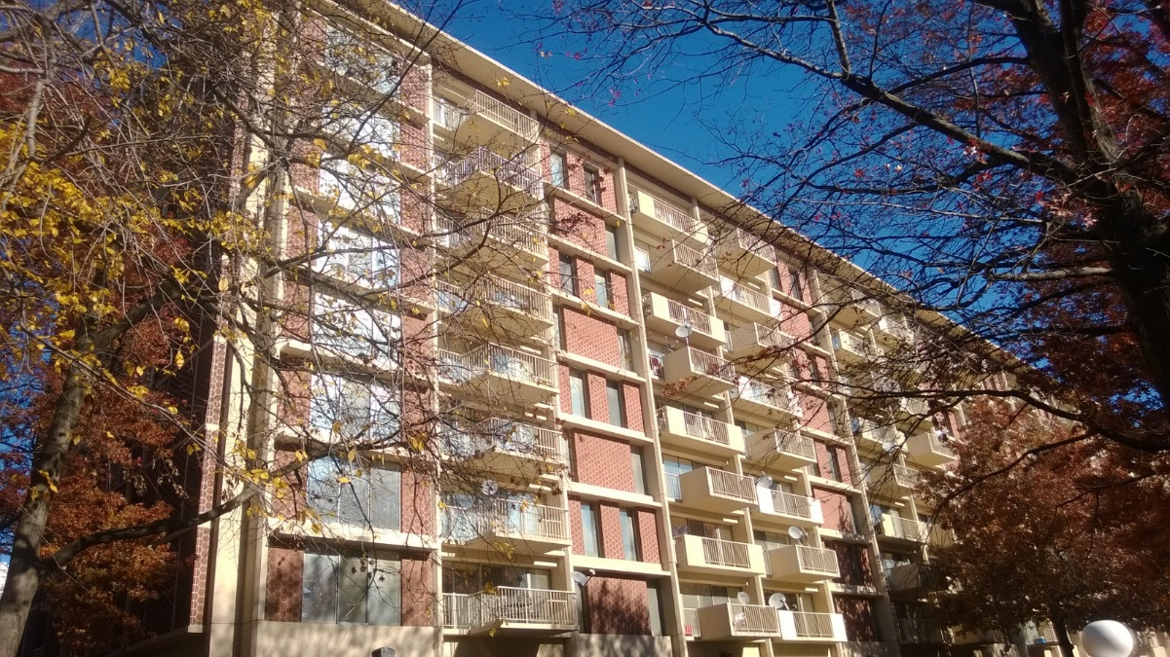

Washington, DC, November 18, 2013 – A group that includes Urban Investment Partners (UIP), PRP LLC, and Perseus Realty has acquired the 289-unit Capitol Park Towers apartment complex in Washington, DC. The group plans to invest in significant improvements over the next several years.

“UIP is excited to be moving into Southwest Washington. We’re very pleased to have reached an agreement with the New Capitol Park Towers Tenants Association that allows for us to preserve another rent controlled property while providing residents with meaningful improvements at the property with no rent increases outside of standard annual increases under rent control,” said Steve Schwat, Principal at UIP.

UIP General Contracting, Inc. (www.uipgc.com), a subsidiary of UIP, will perform the renovation work. UIP subsidiary UIP Property Management, Inc. ([www.uippm.com](http://www.uippm.com)) is property manager.

PRP, LLC is a real estate private equity investment manager that pursues opportunistic real estate investments throughout the United States.

Founded in 2004, Perseus Realty specializes in the acquisition and development of office and residential assets within the Washington, DC metropolitan area. Since its inception, it has owned and operated over one million square feet of space with an additional one million in its development pipeline. For more information, please visit [www.perseusrealty.com](http://www.perseusrealty.com).

Founded in 2001, the UIP family of companies is a leading real estate investment, development, and property management firm based in Washington, DC. The firm invests opportunistically in a variety of asset classes, with a primary focus on multifamily properties in select neighborhoods. Since 2001, UIP’s principals have sponsored real estate funds throughout the DC metropolitan region with a total valuation of over $400 million. For more information about UIP, visit [www.uipllc.com](http://www.uipllc.com).