For immediate release News media contact: Leslie Braunstein,
http://pitch.pe/1AeV264 202/656-0542, info@lhbcommunications.com

UIP, Criterion Acquire Two MD Apartment Communities
For $39.3 Million
Laurel and Glen Burnie Communities Total 385 Units

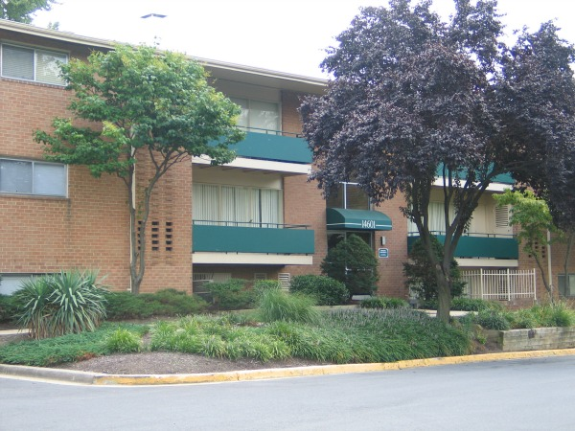

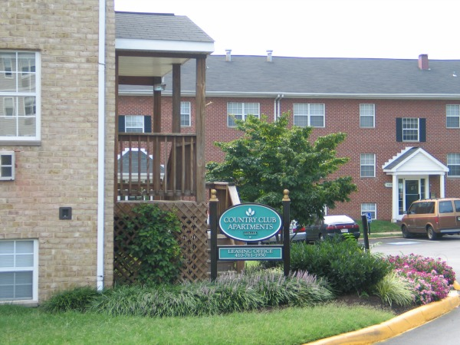

Washington, DC, (November 19, 2014) -- Urban Investment Partners and Criterion Holdings have acquired two Maryland apartment communities with a total of 385 units for $39,340,000. An affiliate of New York City-based Starr Companies provided equity and is a partner in the new ownership group. The seller, represented by CBRE’s Mid-Atlantic Multifamily Investment Sales Team, was a partnership between Boston-based Intercontinental Real Estate and Sawyer Realty Holdings.

Laurel Pines, located at 14601 Bowie Road, sold for $27 million. Most of its 235 garden apartments were built in 1962; 31 units were added in 2010. It is situated just four miles from Fort George G. Meade, Maryland’s largest employer, with some 57,000 employees on more than 5,400 acres. Fort Meade is expected to add more than 20,000 new jobs due to the growth of Federal cyber-security programs.

Country Club Apartments, which traded for $12,340,000, is located at 7491 East Furnace Branch Road in the heart of Glen Burnie. Also built in 1962, this garden apartment community has 150 well-maintained homes. The community is just two miles from Baltimore-Washington Thurgood Marshall International Airport, which employs nearly 10,000 people, eight miles from downtown Baltimore, and nine miles from Fort Meade.

Baltimore-based Criterion Holdings, LLC is the real estate holding company of James Riordan, formerly of Lubert-Adler Partners of Philadelphia. UIP started working with Riordan when he was with Lubert-Adler, and continued the relationship after Riordan left that company in 2012. This is the first completed transaction to result from that partnership.

“Jamie and I have become great friends over the last few years,” said Steve Schwat, Principal, UIP. “That relationship has grown out of our similar instincts and understanding of value-add real estate as well as shared interests such as antique cars.”

UIP Property Management Inc. (UIPPM) will manage the day-to-day operations at both properties, while UIP Asset Management will oversee modest improvements at both locations. Jennie Hawkins, VP of Operations at UIP, oversaw both apartment communities at Sawyer before joining UIP in August. She now oversees all operations for UIPPM and manages a staff of approximately 80.

UIP manages approximately 3,000 apartments in the Washington, DC region and has renovated and restored more than 20 downtown apartment buildings over the last eight years. UIP’s primary focus is working with tenants in Washington, DC and helping them exercise their TOPA (Tenant Opportunity to Purchase Act) rights, as well as entitling land, developing new projects, and acquiring residential assets in the close-in Washington, DC suburbs as well as beyond the Beltway. For more information, visit www.uipllc.com and www.uippm.com.

STARR COMPANIES (or STARR) is the worldwide marketing name for the operating insurance and travel assistance companies and subsidiaries of Starr International Company, Inc. and for the investment business of C. V. Starr & Co., Inc. and its subsidiaries. Starr is a leading insurance and investment organization with a presence on five continents; through its operating insurance companies, Starr provides property, casualty, and accident & health insurance products as well as a range of specialty coverages including aviation, marine, energy and excess casualty insurance. Starr’s insurance company subsidiaries domiciled in the U.S., Bermuda, Hong Kong, and Singapore each possess an A.M. Best rating of “A” (Excellent). Starr’s Lloyd’s syndicate has a Standard & Poor’s rating of “A+” (Strong) while its China subsidiary holds an “A-“(Excellent) rating from A.M. Best.

Photos: Left, Laurel Pines; right: Country Club Apartments

