

For immediate release News media contact: Leslie Braunstein,

<http://pitch.pe/1ChktAy> 202/656-0542, [info@lhbcommunications.com](mailto:info@lhbcommunications.com)

**UIP Completes Renovation at 1430 W Street, NW in DC**

***38 Modern Apartments Now Leasing in 14th Street Corridor***

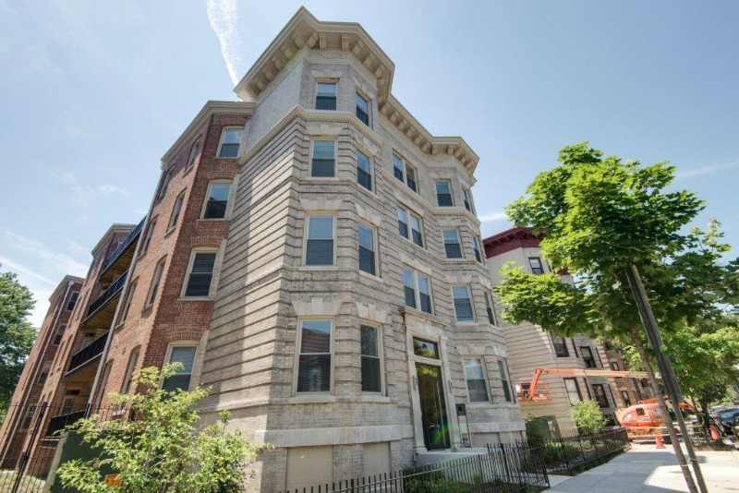

Washington, DC, October 14, 2014 — Urban Investment Partners (UIP) has completed an extensive renovation of a 1910-era apartment building at 1430 W Street, NW, formerly known as The Madeira, transforming it into a Class A building with a full range of 21st century amenities. The building’s 38 modern apartment homes are leasing rapidly.

UIP acquired the building, with 26 dilapidated apartments, in a 2010 foreclosure auction. Since then, UIP’s development team and its construction subsidiary UIP General Contracting, Inc. have completed a $3.8 million total gut renovation that added seven new terrace-level apartments, two of which are ADA accessible, while restoring the building’s historic façade. The team replaced all mechanical, electrical, and plumbing systems, the roof, and all windows. The lobby and hallways were modernized, and two stairwells and sprinkler systems were added.

Located just one block from the heart of the city’s most prominent dining and entertainment destination, 14th Street NW, the 1430 W apartments offer a variety of amenities including controlled access, digital NEST thermostats and smoke detectors, energy-efficient stainless touch appliances, stylish tile bathrooms, gas ranges with glass tile backsplashes, ensuite laundry facilities, and hardwood floors. As in all UIP properties, each apartment is outfitted with combination USB charging outlets for convenient charging of smartphones, laptops, and other digital devices. Sixteen of the newly renovated apartments feature large balconies, some with views of the Washington Monument.

While situated on a quiet side street, 1430 W is located just steps from multiple bus lines and the 14th and U Metro station, as well as such popular restaurants as Kapnos and G by Mike Isabella, Eatonville, Busboys & Poets, and many others. Apartment sizes range from studios to two-bedroom, two-bath units. Monthly rental rates begin at $1,600.00. Leasing and management are being handled by UIP Property Management, Inc.

“This type of renovation and repositioning is a direct bull’s eye in our targeted value-add strategy,” said UIP Co-Founder Steve Schwat. “We are very excited to present another excellent boutique property to the market and look forward to completing a similar renovation at 1483 Newton Street, NW next month.”

UIP manages approximately 3,000 apartments in the Washington, DC region and has renovated and restored more than 20 downtown apartment buildings over the last eight years. UIP’s primary focus is working with tenants in Washington, DC and helping them exercise their TOPA (Tenant Opportunity to Purchase Act) rights, as well as entitling land, developing new projects, and acquiring residential assets in the close-in Washington, DC suburbs. For more information, visit [www.uipllc.com](http://www.uipllc.com), [www.uippm.com](http://www.uippm.com), [www.upigc.com](http://www.upigc.com), and [www.1430w.com](http://www.1430w.com).