For immediate release News media contact: Leslie Braunstein,
202/656-0542, info@lhbcommunications.com http://pitch.pe/19AYV5m
Company contact: Steve Schwat, 202/684-7840

UIP COMPLETES RENOVATION OF APARTMENTS AT
1841 COLUMBIA ROAD IN DC’S ADAMS MORGAN

$7.5 Million Renovation Complete;
Includes Green Roof, Roof Deck, and Energy-Saving HVAC

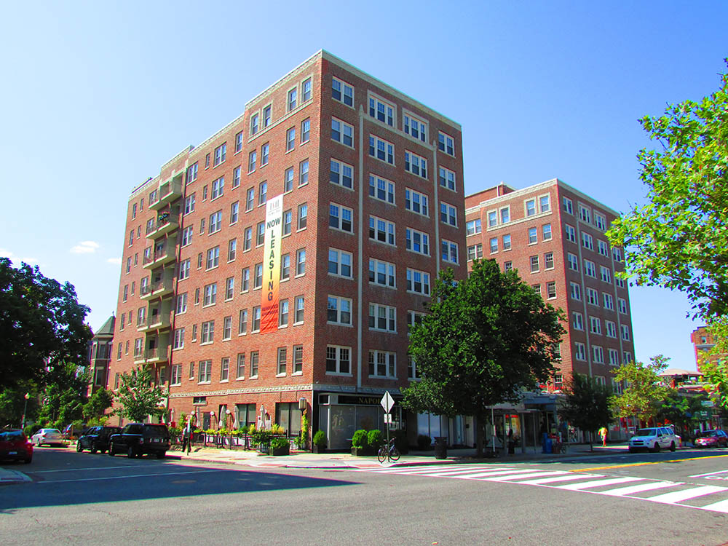

Washington, DC, September 9, 2013– Urban Investment Partners (UIP) is nearing completion of a $7.5 million renovation of the 114-unit, eight-story apartment building at 1841 Columbia Road, NW, in the heart of the city’s storied Adams Morgan neighborhood. 1841 Columbia enjoys an unsurpassed location on the same block as the highly popular restaurants Café Napoleon, Mintwood Place, Cashion’s Eat Place, and Perry’s, as well as Yes! Organic Market. UIP acquired the property last year in partnership with IRE of New York and Lubert-Adler of Philadelphia.

“This has been one of our most exciting projects because of the large scope of work, the building’s prominent location, and the green technology that we have installed,” said UIP Principal Steve Schwat. “Many of the residents with whom we worked to approve the renovation have been very patient and are now just seeing the finished improvements that will make living conditions better for everyone. Long-term residents can now enjoy these improvements without rent increases beyond the standard annual CPI-based amount specified by DC rent control law.” About 38 original residents have remained in their apartments during the renovation.

The building’s 3,150 SF LiveRoof consists of fully grown, low-maintenance native plant species that are visually pleasing. It reduces storm water runoff and carbon dioxide emissions, while reflecting summer heat and absorbing the sun’s energy in winter.

Originally built in 1930, the building formerly known as “The Alcazar” included antiquated features like miniature “servants’ entrances,” old-fashioned radiators, and window air conditioners. UIP’s renovation includes an energy-efficient water-sourced heat pump system with separate controls in each apartment, a green roof, residents’ roof deck with panoramic views of the city, in-home laundry equipment, upgraded electric service, and all-new kitchens and baths. Original wood floors have been restored, and the servants’ entrances have been closed in to provide additional kitchen space. All windows have been replaced with new ones approved by the city’s Historic Preservation Review Board.

The building’s lobby space has been completely transformed. The original “tunnel” entry hall facing Columbia Road, with its worn-out tile and crumbling burgundy curtains, has been added to the property’s 20,000 SF of ground-level and lower-level retail space. StreetSense of Bethesda, MD is representing the ownership in leasing the one remaining available retail space.

The new main entrance lobby on Mintwood Place features bright, modern décor with a blue, yellow, and white palette, a flat-screen TV, lounge area, concierge desk, leasing office, and new mailboxes. For outgoing mail, however, residents can still use the original cast-iron “letter box.”

UIP General Contracting, Inc. (www.uipgc.com), a subsidiary of UIP, is performing the renovation work. UIP subsidiary UIP Property Management, Inc. (www.uippm.com) is property manager.
Founded in 2001, the UIP family of companies is a leading real estate investment, development, and property management firm based in Washington, DC. The firm invests opportunistically in a variety of asset classes, with a primary focus on multifamily properties in select neighborhoods. Since 2001, UIP’s principals have sponsored real estate funds throughout the DC metropolitan region with a total valuation of over $400 million. For more information about UIP visit www.uipllc.com.

Photos: Above: Exterior of 1841 Columbia Road apartments. Below: Green roof installation at 1841 Columbia Road.

